Pied Piper Effect: The influence of hatchery salmon on wild salmon migration

Maria Kuruvilla

2023-06-07

Hatchery salmon play the pied piper by influencing wild salmon to migrate along with them. Study shows social information guides migrating juvenile salmon.

# Abstract

Salmon hatcheries have been releasing juvenile salmon into rivers for over a century in response to the decline of the culturally, ecologically, and economically important Pacific salmon. This study aims to test the “pied piper hypothesis,” which suggests that hatchery salmon may influence wild salmon to migrate earlier, leading to sub-optimal foraging conditions and higher mortality at sea. The study used historical daily count data from the Dungeness river in Washington and multivariate autoregressive state space (MARSS) models to test the hypothesis. The results identified a significant positive effect of number of hatchery salmon on the number of wild salmon migrating downstream for Coho, Chinook, and Steelhead in some years. This suggests that salmon are using social information to determine when to out migrate to the ocean.

# Introduction

Pacific salmon are an ecologically, economically, and culturally important in Washington state. Salmon has been used consistently by the indigenous people for at least 7500 years (Campbell and Butler 2010). However, salmon numbers started declining in Western US a century and a half ago. Nehlsen et al. identified 41 naturally spawning Pacific salmon and steelhead stocks in Washington coast and Puget Sound that are facing high or moderate risk of extinction, or are of special concern (Nehlsen, Williams, and Lichatowich 1991). In response to the continued loss of habitat and decrease in salmon numbers, many salmon and trout hatcheries were developed in Washington with goals to either increase abundance for fishing or to promote conservation of imperiled populations. Hatcheries provide many cultural and economic benefits without which Washington’s salmon fishery would not exist at the scale that it does today.

Salmon hatcheries artificially spawn and rear salmon in controlled environments and then typically release the juvenile salmon into freshwater, where they migrate downstream to rear in natural marine habitats. At this stage, hatchery salmon and wild salmon are potentially directly (socially) or indirectly (through their environment) interacting with each other. The social effects of hatchery salmon on wild salmon have not been studied even though salmon are known to be social at various stages of their life cycle - outmigrating to the ocean in schools (Groot 1965), grouping in the open ocean (Polyakov et al. 2022), and potentially using collective navigation techniques while homing in freshwater (Berdahl et al. 2016). Additionally, social interactions between migrating salmon have been shown to affect migration timing (Berdahl, Westley, and Quinn 2017). The process of seaward migration strongly influence rates of mortality in salmon (Thorstad et al. 2012). Reaching the ocean during unfavourable ocean conditions can drastically decrease marine survival Scheuerell, Zabel, and Sandford (2009). Hence, understanding the factors that affect migration timing of wild salmon smolts is critical for their conservation. However, the effect of the migration of hatchery salmon on wild salmon migration timing has not been considered.

Hatchery salmon are released in large numbers over a small period of time whereas wild smolts have a more protracted outmigration period. These large pulses of salmon smolts migrating downstream could motivate wild salmon to migrate with them potentially causing them to migrate earlier than they normally would and over a shorter period of time Hansen and Jonsson (1985). This is also known as the “pied piper hypothesis”. The pied piper effect could influence wild salmon migration at the seasonal time scale. Wild salmon that are being influenced by hatchery salmon might encounter less than optimal foraging conditions and could encounter more predators thereby experiencing higher mortality at sea (Scheuerell, Zabel, and Sandford 2009). On the other hand, these wild salmon outmigrating with the hatchery salmon might benefit from predator swamping (Furey, Martins, and Hinch 2021). The role of social influence on migration timing is becoming more and more recognized across taxa (Oestreich et al. 2022). Despite anecdotal evidence for the pied piper hypothesis from those running salmon smolt traps, there is a knowledge gap on whether the presence of hatchery salmon influences the behavior of wild salmon during outmigration.

In this paper, we test the ‘pied piper hypothesis’ by analyzing the time series data of the number of wild salmon migrating downstream and the number of hatchery salmon migrating downstream after accounting for the environmental effects in the Dunegness river. The primary objective of this research is to shed light on the fundamentals of salmon behavior and determine whether salmon smolts use social information during outmigration. We find that the number of hatchery salmon in the rivers has a strong positive effect on the number of wild salmon in the river during seaward migration. We find that the effect is variable between years and species. We discuss the potential reasons for this variability and the potential strategies for hatchery reform in Washington state.

# Methods

## River

The Dungeness River is a 28 mile river located in northwest part of Washington State. It originates in the Olympic mountains and drains into the Strait of Juan de Fuca. The Dungeness river is fed through melting snowpack from the Olympics as well as the rain. The lowest flows are in August-September whereas the highest temperature is around 15 degree Celsius in July-August. The Dungeness River supports five species of salmonids - Chinook, Coho, Chum, Pink, and Steelhead. There are multiple hatcheries that release Chinook, Coho and Steelhead salmon into the river at various stages. The Dungeness River hatchery, Gray Wolf, Hurd Creek, and Upper Dungeness hatchery are the main hatcheries on the Dungeness River.

## Data

### Smolt trap data

Rotatry screw traps along with a variety of other techniques are used to monitor salmon smolts that migrate from their natal sites to the ocean. The smolts that are caught in the trap and enumerated and and recorded twice a day. In this paper, I have used data collected using a rotatory screw trap monitored by the Washington Department of Fish and Wildlife (WDFW) in the Dungeness river. To test the ‘pied piper hypothesis’ or the influence of hatchery salmon on the migration timing of wild salmon, we used a subset of the data of species with a hatchery program in the Dungeness river. Namely, we collated data representing Coho yearlings, Chinook subyearlings, and Steelhead smolts. The hatchery origin fish are identified by the code wire tag, the adipose fin clipped or by their size when the fish are unmarked and unclipped (<5% for coho and steelhead and <12% for chinook). Since the salmon smolts caught in the trap are counted at a different time everyday and since the number of hours for which the trap is operating in the river varies everyday, we took the sum of the all the salmon smolts migrating on a given day and divided by the number of hours that the trap was operating that day to give the number of fish per hour for each species and origin. While the trap usually operates from February to September for each year, for the analysis we only considered the time period of migration for each species. For coho and steelhead, we used data from day of year $=120$ to day of year $=160$. While chinook subyearlings have multiple migration strategies with some fish migrating in spring and some migrating in early summer, the hatchery chinook releases overlap with the summer migration. Therefore, we used only the data corresponding to the summer migration from day of year $=130$ to day of year $=200$. For each species, we log transformed the data (after adding 1 to each data point to avoid infinite values) since we found that the data was log normally distributed. Since the number of wild fish migrating varies widely from year to year, we scaled and centered the data to be able to compare between the years. Since we wanted the hatchery fish numbers to remain $0$ when no hatchery fish are caught in the trap, we only scaled the hatchery fish data.

### Environmental data

To account for the effect of environmental variables on the migration of wild salmon, we selected environmental covariates based on prior research Spence and Dick (2014) and collated environmental data from various websites.

#### Temperature

We collected temperature data for years 2005-2014 from the Washington Department of Ecology website <https://ecology.wa.gov/>. The water temperature was measured at a station located approximately 1000 ft from the Dungeness hatchery. For the years 2016-2020, we used temperature data collected by a logger near the trap. However, data from 2015 was missing. Therefore, we did not consider the data from year 2015 for the initial model selection. However, if temperature (or releated covariates) was not a covariate in the most parsimonious model, we included data from 2015 in the final model.

#### Accumulated thermal units

We calculated ‘accumulated thermal units april’ as the cumulative sum of the temperature experienced since April 1st.

#### Photoperiod

We calculated day light hours for a given day using <https://api.sunrise-sunset.org> for latitude 48.11591 and longitude -123.14318, a point on the Dungeness River between the hatchery and the trap. Since temperature, accumulated thermal units, and photoperiod are highly correlated, we fit separate models with each of these covariates and chose the most parsimonious model before including other covariates.

#### Residuals

We first fitted a linear model to the temperature data with photoperiod as a covariate. We then used the residuals of this model as a covariate in our models as an indicator of the additional effect of temperature after controlling for the length of the day. A positive effect of residuals would indicate that the fish are more likely to migrate on a unseasonably warm day.

#### Flow

Since stream flow is known to effect migration timing of coho (Spence and Dick 2014), we included flow as a covariate. We collected flow data in cubic feet per second for the years 2005-2020 from the Washington Department of Ecology. Flow was measured at a station located approximately 1000 ft from the Dungeness hatchery.

#### Lunar phase

Since lunar phase is known to effect the migration timing of coho (Spence and Dick 2014) and chinook subyearlings (Roper and Scarnecchia 1999), we calculated the percentage of the moon illuminated for a given date and used it as a covariate in the model.

## Analysis

We used the multivariate auto regressive state-space (MARSS) model to estimate the influence of the number of hatchery salmon in the river, and the different environmental variables on the number of wild salmon migrating (Hinrichsen and Holmes 2009). MARSS models have been used to analyse time series data that are auto correlated. Since MARSS does not allow missing data in the covariates, we interpolated the number oh hatchery fish per hour to fill the missing values that correspond to the few days during which the trap was not operating. In the MARSS framework, $y_{t}$ is the independent observations of fish at time t and $x_{t}$ represents the number of wild salmon at time t that are autocorrelated.

$$y_{t}=log{\left(\text{number of observed fish per hour + 1}\right)}_{t}$$

$$x_{t}=log{\left(\text{number of fish per hour + 1}\right)}_{t}$$

They are related by the following equations:

$$y_{t}=Zx_{t}+a_{t}+Dd_{t}+v_{t},v_{t}∼MVN(0,R)$$

$$x_{t}=Bx_{t−1}+u_{t}+Cc_{t}+w_{t},w_{t}∼MVN(0,Q)$$

where $c_{t}$ are the covariates affecting the states or the average number of fish in the river, $C$ are the effects of the covariates $c_{t}$ on $x_{t}$, $d_{t}$ are the covariates affecting the observations or effecting deviations from an average level, $D$ are the effects of the covariates on the observation. $w_{t}$ and $v_{t}$ are the normally distributed errors. $R$ is the variance-covariance matrix of the observation errors and $Q$ is the variance-covariance matrix of the process errors. We assume that the observations and states are independent between years. Therefore $Z$ and $B$ are identity matrices in our model. We assume that the observation and process errors are the same for all years. Therefore, $R$ and $Q$ are diagonal matrices with all diagonal elements set to be equal. We assumed that the the effect of environmental covariates to be the same every year. However, we allowed the effect of hatchery fish to be different every year.

$$\begin{matrix}{\left[\begin{matrix}y_{2005} \\ ⋮ \\ y_{2020}\end{matrix}\right]}_{t}=\left[\begin{matrix}1 & 0 & 0 & ... & 0 \\ 0 & 1 & 0 & ... & 0 \\ & & ⋱ & \\ 0 & 0 & 0 & .. & 1\end{matrix}\right]{\left[\begin{matrix}x_{2005} \\ ⋮ \\ x_{2020}\end{matrix}\right]}_{t}+ \\ \\ \left[\begin{matrix}d_{2005} & 0 & 0 & ... & 0 \\ 0 & d_{2006} & 0 & ... & 0 \\ & & ⋱ & \\ 0 & 0 & 0 & .. & d_{2020}\end{matrix}\right]{\left[\begin{matrix}hatchery_{2005} \\ ⋮ \\ hatchery_{2020}\end{matrix}\right]}_{t}+\left[\begin{matrix}a_{2005} \\ ⋮ \\ a_{2020}\end{matrix}\right]+{\left[\begin{matrix}v_{2005} \\ ⋮ \\ v_{2020}\end{matrix}\right]}_{t}\end{matrix}$$

where,

$${\left[\begin{matrix}v_{2005} \\ ⋮ \\ v_{2020}\end{matrix}\right]}_{t}∼MVN\left(0,\left[\begin{matrix}r & 0 & 0 & ... \\ 0 & r & 0 & ... \\ 0 & 0 & 0 & ⋱ \\ 0 & 0 & 0 & ...r\end{matrix}\right]\right)$$

.

$$\begin{matrix}{\left[\begin{matrix}x_{2005} \\ ⋮ \\ x_{2020}\end{matrix}\right]}_{t}=\left[\begin{matrix}1 & 0 & 0 & ... & 0 \\ 0 & 1 & 0 & ... & 0 \\ & & ⋱ & \\ 0 & 0 & 0 & .. & 1\end{matrix}\right]{\left[\begin{matrix}x_{2005} \\ ⋮ \\ x_{2020}\end{matrix}\right]}_{t−1}+ \\ \\ \left[\begin{matrix}c_{1} & c_{2} & c_{3} & 0 & 0 & ... & 0 \\ 0 & c_{1} & c_{2} & c_{3} & 0 & ... & 0 \\ & & ⋱ & \\ 0 & 0 & 0 & 0 & 0 & .. & c_{3}\end{matrix}\right]{\left[\begin{matrix}photoperiod_{2005} \\ lunar phase_{2005} \\ flow_{2005} \\ ⋮ \\ flow_{2020}\end{matrix}\right]}_{t}+\left[\begin{matrix}u_{2005} \\ ⋮ \\ u_{2020}\end{matrix}\right]+{\left[\begin{matrix}w_{2005} \\ ⋮ \\ w_{2020}\end{matrix}\right]}_{t}\end{matrix}$$

where,

$${\left[\begin{matrix}w_{2005} \\ ⋮ \\ w_{2020}\end{matrix}\right]}_{t}∼MVN\left(0,\left[\begin{matrix}q & 0 & 0 & ... \\ 0 & q & 0 & ... \\ 0 & 0 & 0 & ⋱ \\ 0 & 0 & 0 & ...q\end{matrix}\right]\right)$$

.

### Model diagnostics

We plotted the residuals of the predicted $y_{t}$ values against the fitted values, autocorrelation function of the residuals,= as well as quantile-quantile plots to ensure that the data met the model assumptions of being identical, independent, and normally distributed.

### Model selection

Akaike Information Criterion (AIC) is often used to select the best model among models with different combinations of covariates. However, with autocorreleated data, the sample size is much lower than the number of data points we have. Thus, we used AICc, which is AIC with a correction factor for small sample size, to compare models.

# Results

## Coho yearlings

We found that model with the lowest AICc had photoperiod and flow as process covariates and hatchery as an observation covariate. The effect of photoperiod and flow were negative implying that the number of coho migrating decreased as photoperiod increased and the number of coho migrating decreased when flow increased. The effect of hatchery coho on the number of wild coho varied from year to year. We found that hatchery coho had a significant and positive effect on wild coho in years 2005, 2008, 2009, and 2010, and a slight positive effect on wild coho in years 2016, 2018, and 2019. Hatchery coho had a slight negative effect on wild coho in 2007.

## Chinook subyearlings

We found that model with the lowest AICc had ATU (accumulated thermal units) as a process covariate and hatchery as an observation covariate. The effect of ATU was negative implying that the number of chinook migrating decreased as ATU increased. The effect of hatchery chinook on the number of wild chinook varied from year to year. We found that hatchery chinook had a significant and positive effect on wild chinook in years 2006, 2008, 2009, 2011, 2012, 2013, 2014, 2016 and 2018, and a slight positive effect on wild coho in years 2007, 2010, and 2019.

## Steelhead smolts

We found that the model with the lowest AICc had photoperiod and photoperiod $​^{2}$ as process covariates and hatchery as an observation covariate. The effect of photoperiod was negative and the effect of photoperiod $​^{2}$ was positive. The effect of hatchery steelhead smolts on the number of wild steelhead smolts varied from year to year. We found that hatchery steelhead smolts had a significant positive effect on wild steelhead smolts in years 2005, 2007, 2008, 2009, 2010, and 2015.

# Discussion

Our primary objective was to determine whether juvenile salmon outmigrating to the ocean use social information to decide the timing of migration and whether the large hatchery releases in the Dungeness river has an effect on the number of wild salmon migrating on a given day. Our results indicates that the large number of hatchery salmon migrating downstream has a significant positive effect on the number of wild salmon migrating downstream.

Various strategies are implemented to release hatchery salmon into the Dungeness river. According to the Regional Mark Information System (RMIS) website, these strategies are forced release, volitional release and mixed release. While the release strategy was not recorded before 2009, the release strategies between 2009 and 2015 has been mostly forced releases and mixed releases. Volitional releases have been more common in the recent years. If release strategies are influencing the movement patterns of hatchery salmon and the duration of their migration, this would explain why the influence of hatchery salmon on wild salmon is lower in recent years.

Our results indicate that juvenile salmon are likely using social information while making decisions on when to migrate from freshwater to the ocean. It is possible that juvenile salmon may benefit from aggregating and synchronizing their migration timing, as this behavior increases their overall survival rate and minimizes the risks associated with predators, competition for resources, and unfavorable environmental conditions. However, it is also possible that social information from hatchery salmon can cause wild juvenile salmon to migrate earlier than they otherwise would. Juvenile salmon could face sub optimal ocean conditions when entering the ocean which decreases their chance of survival. While our findings provide strong evidence supporting the role of social information in juvenile salmon migration, further research is needed to fully elucidate the specific mechanisms involved and the consequences of the pied piper effect on wild salmon.

# Figures and Tables



Figure 1. Raw data of number of coho per hour caught in the trap starting from first hatchery release. Blue lines represent number of hatchery coho per hour and orange lines represent number wild coho per hour.

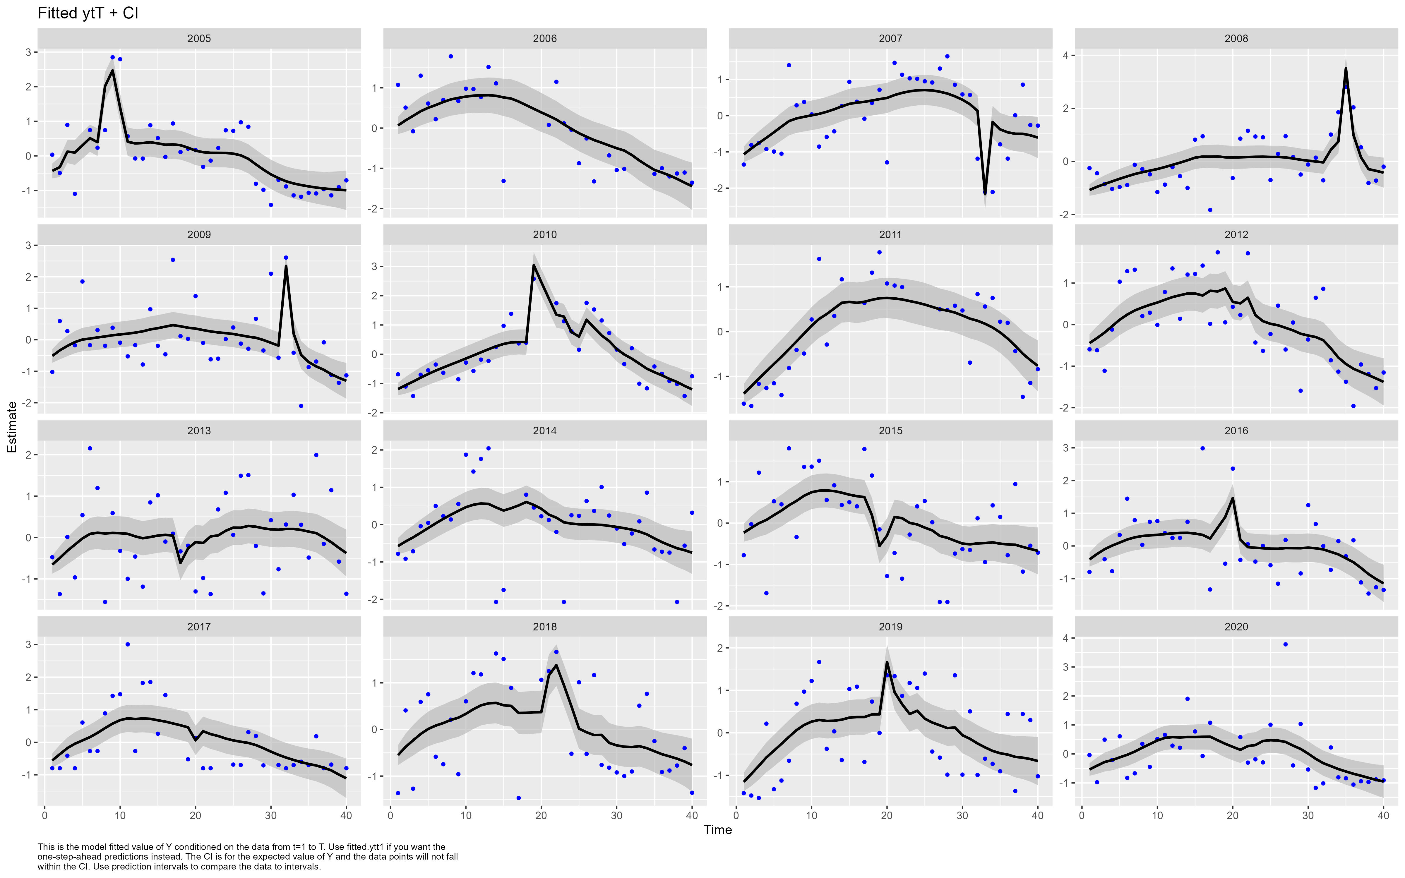

Figure 2. Fitted values of $y_{t}$ for coho yearlings

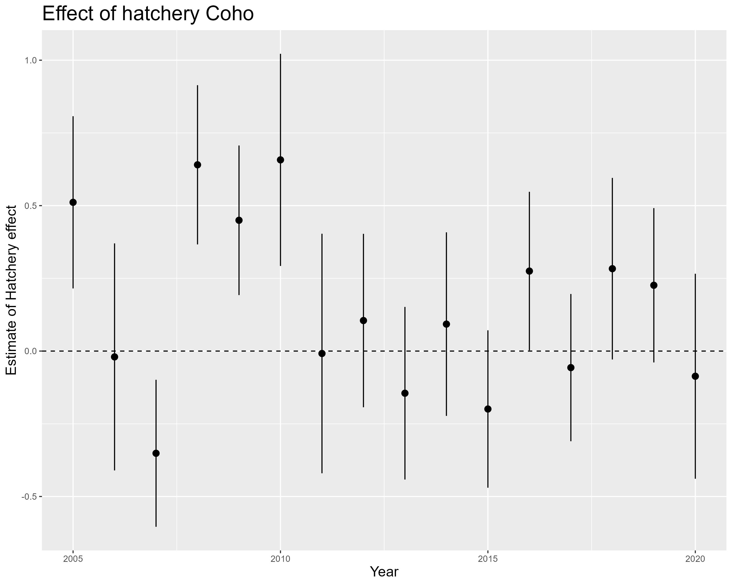

Figure 3. Effect of hatchery coho on wild coho for each year with 95% confidence intervals



Figure 4. Raw data of number of chinook per hour caught in the trap starting from first hatchery release. Blue lines represent number of hatchery chinook per hour and orange lines represent number wild chinook per hour.

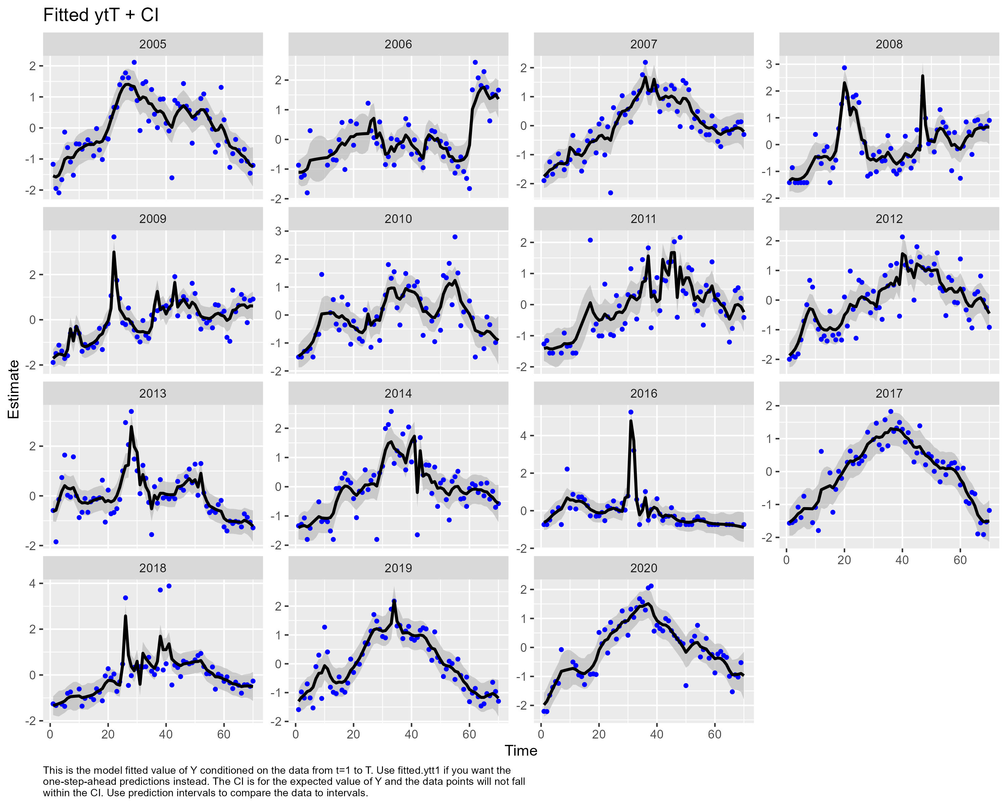

Figure 5. Fitted values of $y_{t}$ of chinook subyearlings

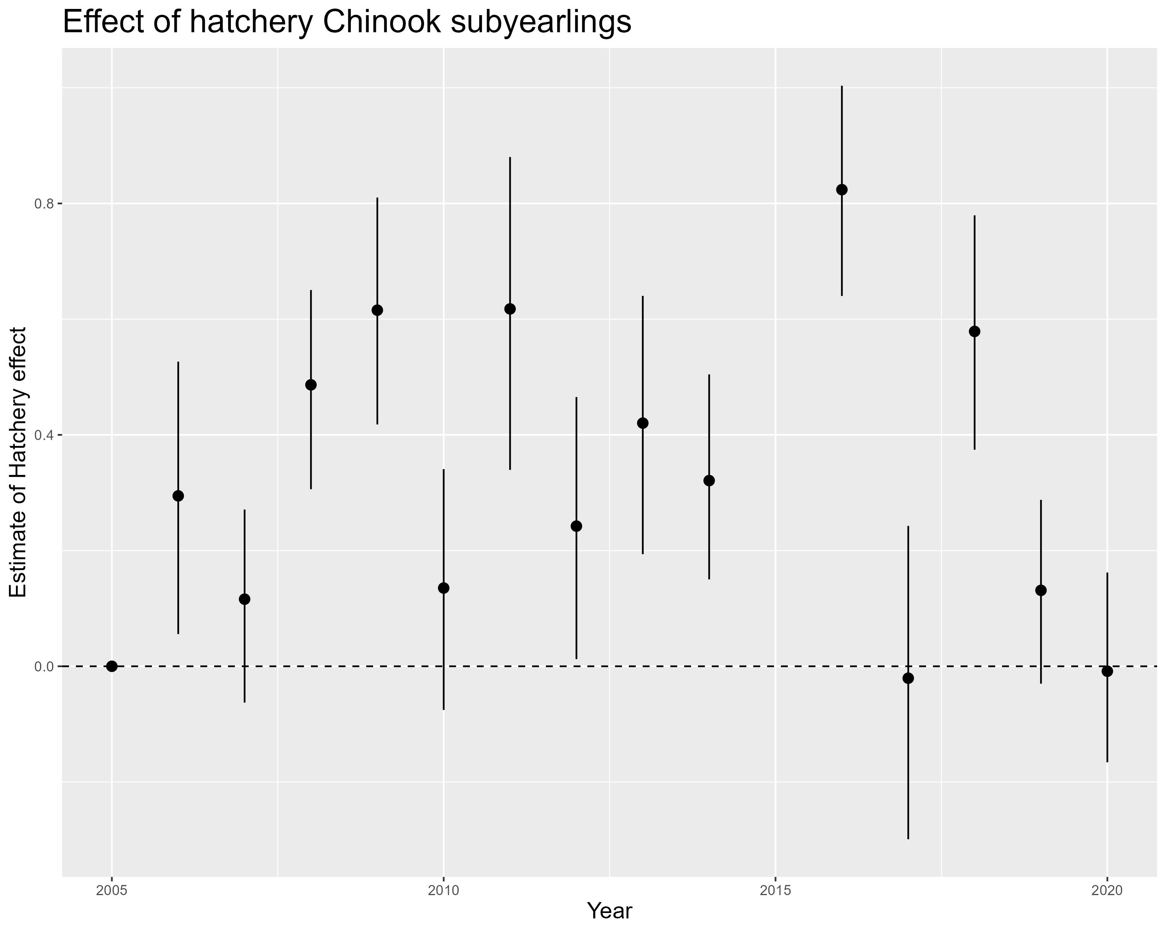

Figure 6. Effect of hatchery chinook on wild chinook for each year with 95% confidence intervals



Figure 7. Raw data of number of steelhead per hour caught in the trap starting from first hatchery release. Blue lines represent number of hatchery steelhead per hour and orange lines represent number wild steelhead per hour.

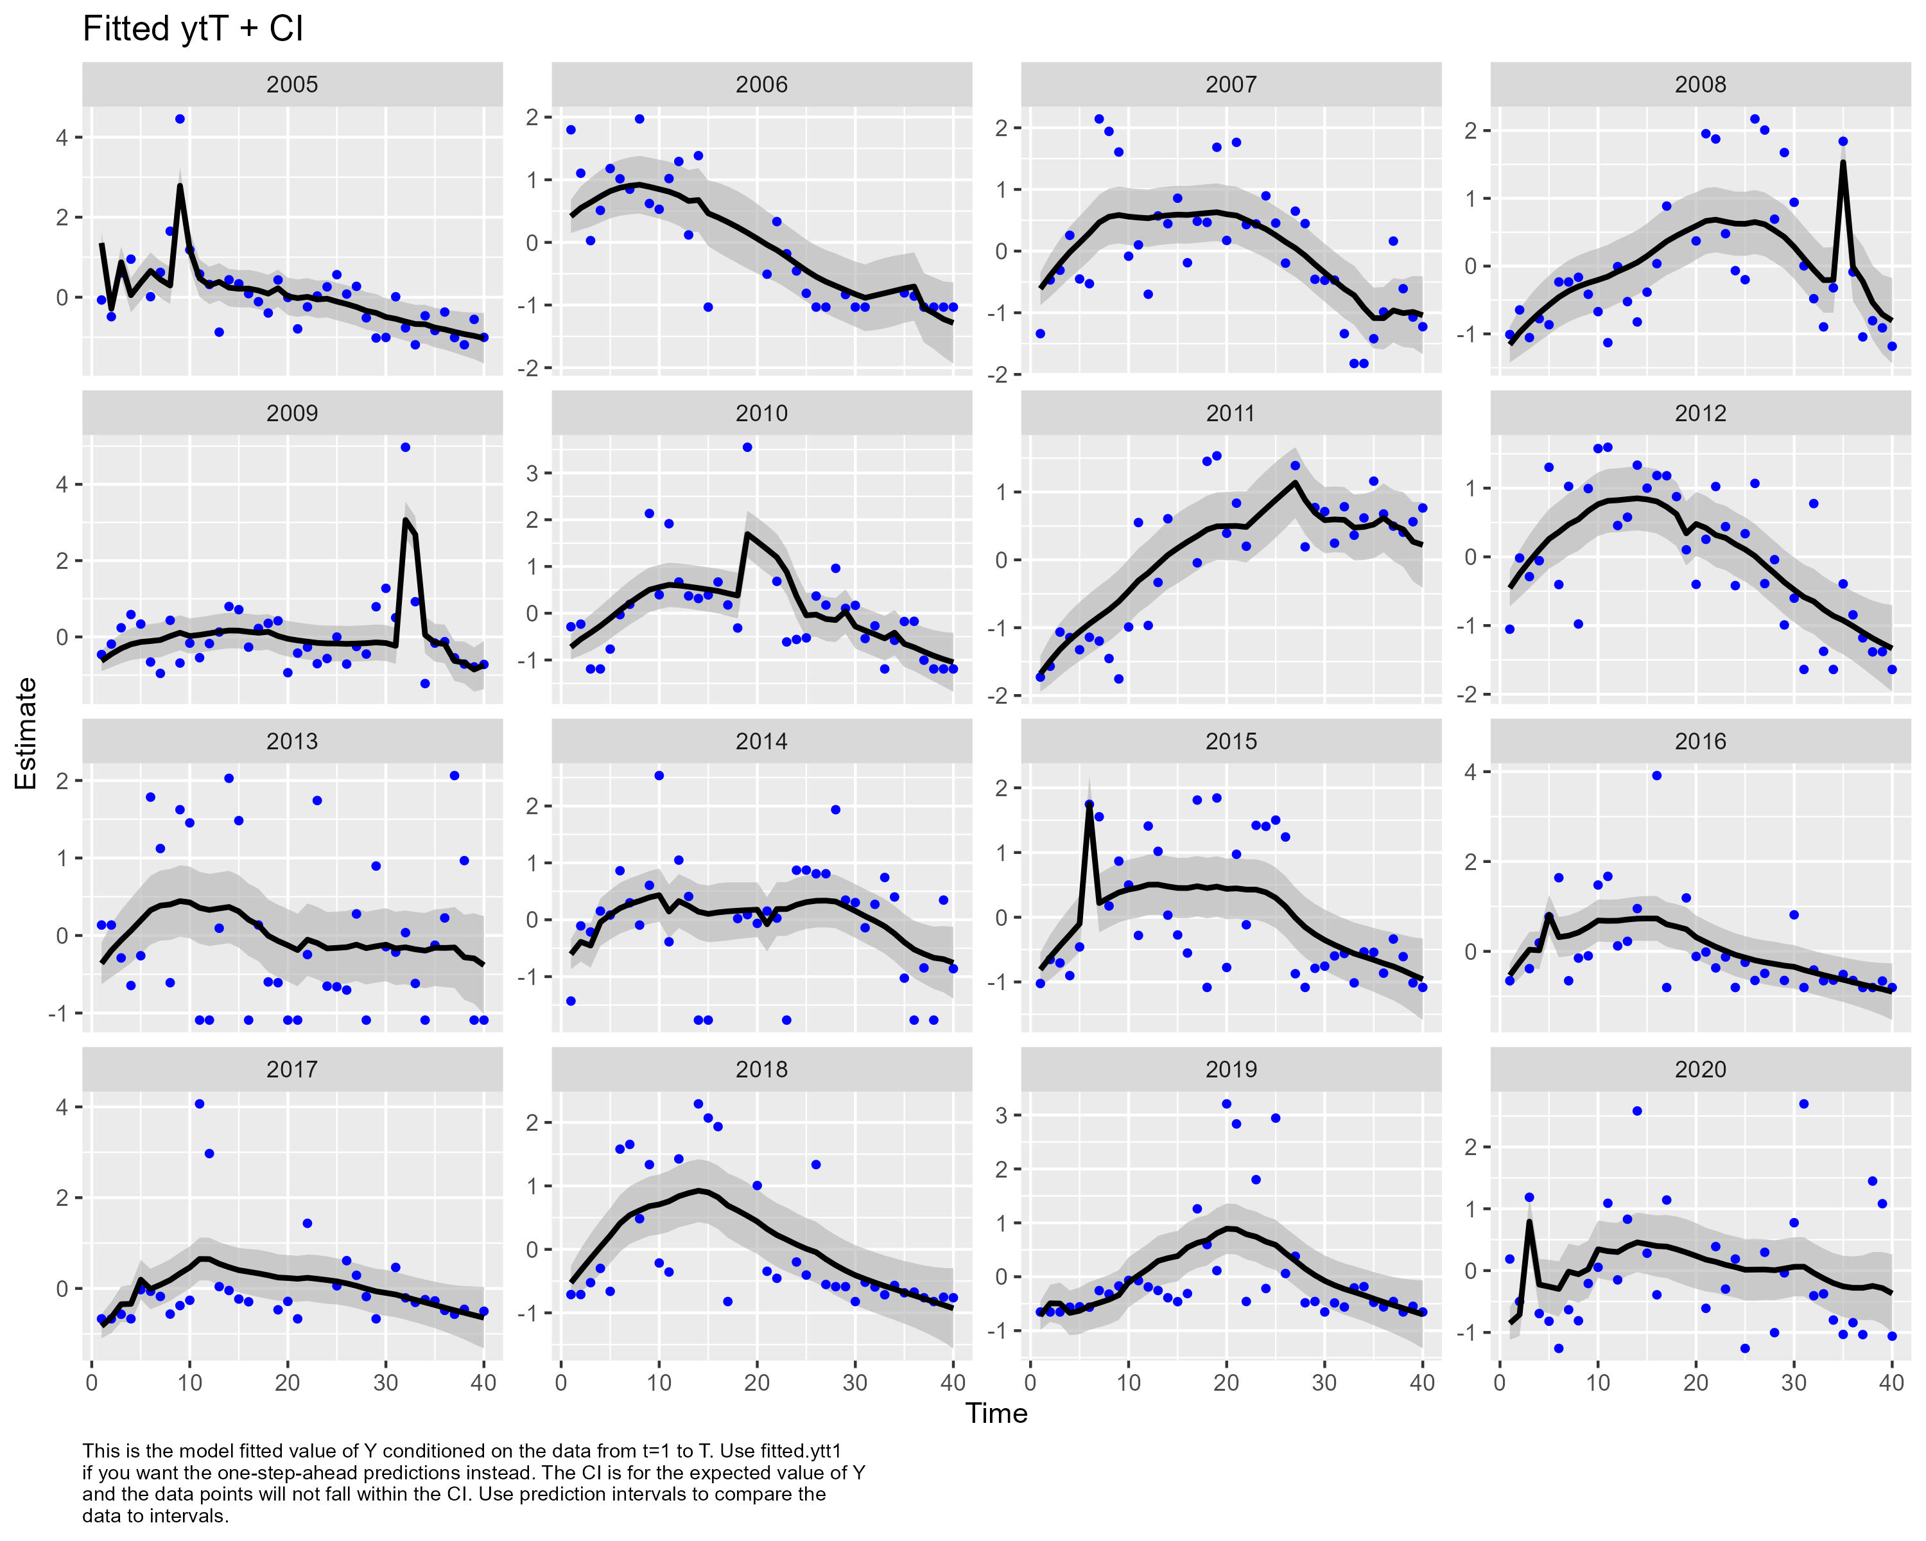

Figure 8. Fitted values of $y_{t}$ of steelhead smolts

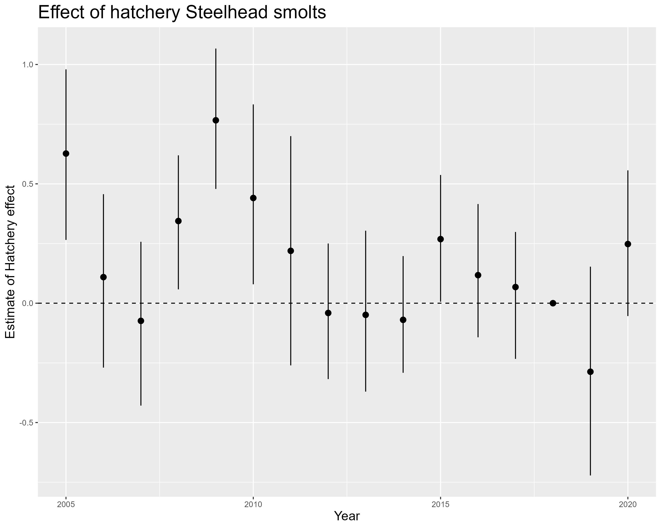

Figure 9. Effect of hatchery steelhead on wild steelhead for each year with 95% confidence intervals

Table 1. Model selection for Coho yearlings

| Process covariates | Observation covariates | AICc | Delta AICc |
| --- | --- | --- | --- |
| Flow, Photoperiod | Hatchery | 1424 | 0 |
| Temperature residuals, Flow, Photoperiod | Hatchery | 1426 | 2 |
| Photoperiod | Hatchery | 1428 | 4 |
| Temperature residuals, Photoperiod | Hatchery | 1430 | 6 |
| Lunar phase, Photoperiod | Hatchery | 1430 | 6 |
| ATU | Hatchery | 1432 | 8 |
| Temperature | Hatchery | 1444 | 20 |
| None | Hatchery | 1474 | 50 |
| None | None | 1505 | 81 |

Table 2. Model selection for Chinook subyearlings

| Process covariates | Observation covariates | AICc | Delta AICc |
| --- | --- | --- | --- |
| ATU | Hatchery | 2075 | 0 |
| Flow, ATU | Hatchery | 2075 | 0 |
| Temperature residuals, ATU | Hatchery | 2076 | 1 |
| Temperature | Hatchery | 2077 | 2 |
| Lunar phase, ATU | Hatchery | 2078 | 3 |
| Photoperiod | Hatchery | 2084 | 9 |
| None | Hatchery | 2091 | 16 |
| None | None | 2273 | 198 |

Table 3. Model selection for Steelhead smolts

| Process covariates | Observation covariates | AICc | Delta AICc |
| --- | --- | --- | --- |
| Photoperiod, Photoperiod square | Hatchery | 1461 | 0 |
| Photoperiod, Photoperiod square, Flow | Hatchery | 1463 | 2 |
| Photoperiod | Hatchery | 1464 | 3 |
| Photoperiod, Photoperiod square, Lunar phase | Hatchery | 1467 | 6 |
| ATU | Hatchery | 1468 | 7 |
| Photoperiod, Photoperiod square, Temperature residuals | Hatchery | 1468 | 7 |
| Temperature | Hatchery | 1484 | 23 |
| Flow, Flow square | Hatchery | 1488 | 27 |
| Temperature, Temperature square | Hatchery | 1489 | 28 |
| None | Hatchery | 1491 | 30 |
| None | None | 1509 | 48 |

# References

Berdahl, Andrew, Peter A. H. Westley, and Thomas P. Quinn. 2017. “Social Interactions Shape the Timing of Spawning Migrations in an Anadromous Fish.” *Animal Behaviour* 126 (April): 221–29. <https://doi.org/10.1016/j.anbehav.2017.01.020>.

Berdahl, Andrew, Peter AH Westley, Simon A Levin, Iain D Couzin, and Thomas P Quinn. 2016. “A Collective Navigation Hypothesis for Homeward Migration in Anadromous Salmonids.” *Fish and Fisheries* 17 (2): 525–42.

Bilton, H. T., D. F. Alderdice, and J. T. Schnute. 1982. “Influence of Time and Size at Release of Juvenile Coho Salmon (Oncorhynchus Kisutch) on Returns at Maturity.” *Canadian Journal of Fisheries and Aquatic Sciences* 39 (3): 426–47. <https://doi.org/10.1139/f82-060>.

Campbell, Sarah K., and Virginia L. Butler. 2010. “Archaeological Evidence for Resilience of Pacific Northwest Salmon Populations and the Socioecological System over the Last ~7,500 Years.” *Ecology and Society* 15 (1). <https://www.jstor.org/stable/26268107>.

Furey, Nathan B, Eduardo G Martins, and Scott G Hinch. 2021. “Migratory Salmon Smolts Exhibit Consistent Interannual Depensatory Predator Swamping: Effects on Telemetry-Based Survival Estimates.” *Ecology of Freshwater Fish* 30 (1): 18–30.

Groot, Cornelis. 1965. “On the Orientation of Young Sockeye Salmon (Oncorhynchus Nerka) During Their Seaward Migration Out of Lakes.” *Behaviour. Supplement*, I–198.

Hansen, Lars P., and Bror Jonsson. 1985. “Downstream Migration of Hatchery-Reared Smolts of Atlantic Salmon (Salmo Salar L.) In the River Imsa, Norway.” *Aquaculture*, Salmonid Smoltification II, 45 (1): 237–48. <https://doi.org/10.1016/0044-8486(85)90273-X>.

Hinrichsen, Richard, and Elizabeth Holmes. 2009. “Using Multivariate State-Space Models to Study Spatial Structure and Dynamics,” August. <https://doi.org/10.1201/9781420059861.ch8>.

Kennedy, GJA, CD Strange, RJD Anderson, and PM Johnston. 1984. “Experiments on the Descent and Feeding of Hatchery-Reared Salmon Smolts (Salmo salarL.) In the River Bush.” *Aquaculture Research* 15 (1): 15–25.

Nehlsen, Willa, Jack E. Williams, and James A. Lichatowich. 1991. “Pacific Salmon at the Crossroads: Stocks at Risk from California, Oregon, Idaho, and Washington.” *Fisheries* 16 (2): 4–21. <https://doi.org/10.1577/1548-8446(1991)016<0004:PSATCS>2.0.CO;2>.

Oestreich, William K., Kanoe M. Aiu, Larry B. Crowder, Megan F. McKenna, Andrew M. Berdahl, and Briana Abrahms. 2022. “The Influence of Social Cues on Timing of Animal Migrations.” *Nature Ecology & Evolution* 6 (11): 1617–25. <https://doi.org/10.1038/s41559-022-01866-0>.

Polyakov, Anne Y, Thomas P Quinn, Katherine W Myers, and Andrew M Berdahl. 2022. “Group Size Affects Predation Risk and Foraging Success in Pacific Salmon at Sea.” *Science Advances* 8 (26): eabm7548.

Roper, Brett B., and Dennis L. Scarnecchia. 1999. “Emigration of Age-0 Chinook Salmon (Oncorhynchus Tshawytscha) Smolts from the Upper South Umpqua River Basin, Oregon, U.S.A.” 56.

Scheuerell, Mark D., Richard W. Zabel, and Benjamin P. Sandford. 2009. “Relating Juvenile Migration Timing and Survival to Adulthood in Two Species of Threatened Pacific Salmon (Oncorhynchus Spp.).” *Journal of Applied Ecology* 46 (5): 983–90. <https://doi.org/10.1111/j.1365-2664.2009.01693.x>.

Spence, Brian C., and E. J. Dick. 2014. “Geographic Variation in Environmental Factors Regulating Outmigration Timing of Coho Salmon ( *Oncorhynchus Kisutch* ) Smolts.” Edited by Ian Fleming. *Canadian Journal of Fisheries and Aquatic Sciences* 71 (1): 56–69. <https://doi.org/10.1139/cjfas-2012-0479>.

Sykes, Gregory E., Chris J. Johnson, and J. Mark Shrimpton. 2009. “Temperature and Flow Effects on Migration Timing of Chinook Salmon Smolts.” *Transactions of the American Fisheries Society* 138 (6): 1252–65. <https://doi.org/10.1577/T08-180.1>.

Thorstad, E. B., F. Whoriskey, I. Uglem, A. Moore, A. H. Rikardsen, and B. Finstad. 2012. “A Critical Life Stage of the Atlantic Salmon Salmo Salar: Behaviour and Survival During the Smolt and Initial Post-Smolt Migration.” *Journal of Fish Biology* 81 (2): 500–542. <https://doi.org/10.1111/j.1095-8649.2012.03370.x>.